Resemble.js analyses and compares images with HTML5 canvas and JavaScript.

It can be used to verify picture identification.

<https://rsmbl.github.io/Resemble.js/>

<https://medium.com/@royyeh007/how-to-use-resemble-js-api-with-react-to-compare-images-e1d1871dd068>

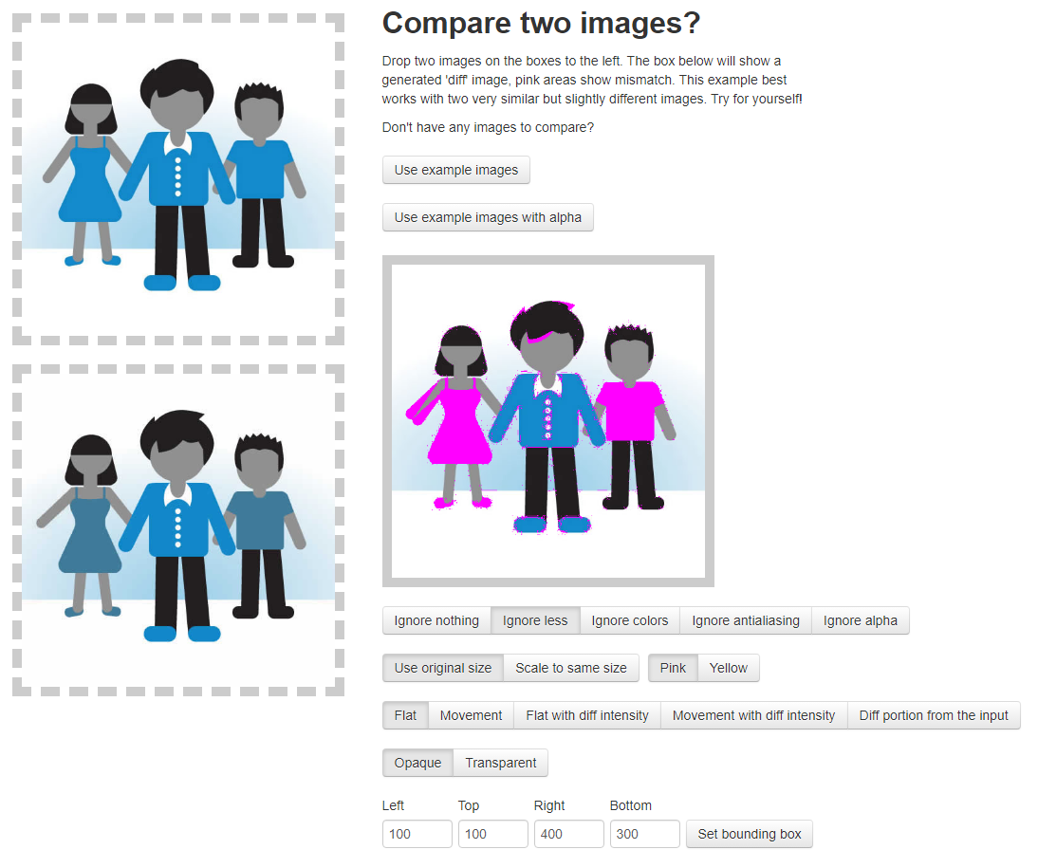

This library can be used to auto or manually crop uploaded images

<https://www.npmjs.com/package/react-image-crop>

<https://medium.com/swlh/adding-crop-before-upload-in-react-22dfcf3a95b7>

<https://levelup.gitconnected.com/image-crop-using-react-js-37e10208c572>